**RAC INSTALLATIONS OF TWO NODES**

**Perform these actions as a root user across the nodes**

**1)install the rpms as**

binutils-2.17.50.0.6

compat-libstdc++-33-3.2.3

compat-libstdc++-33-3.2.3 (32 bit)

       elfutils-libelf-0.125

elfutils-libelf-devel-0.125

gcc-4.1.2

gcc-c++-4.1.2

glibc-2.5-24

glibc-2.5-24 (32 bit)

glibc-common-2.5

glibc-devel-2.5

glibc-devel-2.5 (32 bit)

glibc-headers-2.5

ksh-20060214

libaio-0.3.106

libaio-0.3.106 (32 bit)

libaio-devel-0.3.106

libaio-devel-0.3.106 (32 bit)

libgcc-4.1.2

libgcc-4.1.2 (32 bit)

libstdc++-4.1.2

libstdc++-4.1.2 (32 bit)

libstdc++-devel 4.1.2

make-3.81

sysstat-7.0.2

unixODBC-2.2.11

unixODBC-2.2.11 (32 bit)

unixODBC-devel-2.2.11

unixODBC-devel-2.2.11 (32 bit)

cvuqdisk-1.0.9-1.rpm

oracleasm-2.6.18-194.el5xen-2.0.5-1.el5.x86_64.rpm

oracleasmlib-2.0.4-1.el5.x86_64.rpm

oracleasm-support-2.1.3-1.el5.x86_64.rpm

**2)Adding users and groups**

#groupadd –g 1000 dba

#groupadd –g 1001 oinstall

#groupadd -g 1002 asmdba

#groupadd –g 1003 asmoper

#groupadd –g 1004 asmadmin

#useradd –u 2000 -g oinstall –G dba,asmdba,asmoper,asmadmin gridsp01

# useradd –u 2001 -g oinstall –G dba,asmdba orasp01

**3) Make sure the shared memory filesystem is big enough for Automatic Memory Manager to work.**

**EXAMPLES:**

# umount tmpfs

# mount -t tmpfs tmpfs -o size=9.7g /dev/shm

( size is based upon 90% of physical memory)

**NOTE:Make the setting permanent by amending the "tmpfs" setting of the "/etc/fstab" file to look like this.**

tmpfs                   /dev/shm                tmpfs   defaults,size=9.7g      0 0

**4)Editing the host files**

**#vi /etc/hosts**

127.0.0.1 localhost.localdomain localhost

::1 localhost.localdomain localhost6 localhost

##PUBLIC IP##

192.168.22.31 sreikolsefl1.srei.com sreikolsefl1

192.168.22.34 sreikolsef12.srei.com sreikolsef12

##PRIVATE IP##

192.168.5.3 sreikolpriv3.srei.com sreikolpriv3

192.168.5.4 sreikolpriv4.srei.com sreikolpriv4

##VIRTUAL IP##

192.168.22.32 sreikolvipsp1.srei.com sreikolvipsp1

192.168.22.42 sreikolvipsp2.srei.com sreikolvipsp2

:x!

Be sure to nslookup all the public,vip and scan IPs and hostnamesas follows and also they should be pingable to each other.

$nslookup sreikolsefl1

**5)Setting Kernel parameters**

Vi /etc/sysctl.conf

kernel.msgmnb = 65536

kernel.msgmax = 65536

kernel.shmmax = 68719476736

kernel.shmall = 4294967296

fs.aio-max-nr = 1048576

fs.file-max = 6815744

kernel.shmmni = 4096

kernel.sem = 250 32000 100 128

net.ipv4.ip_local_port_range = 9000 65500

net.core.rmem_default = 262144

net.core.rmem_max = 4194304

net.core.wmem_default = 262144

net.core.wmem_max = 1048586

:x

The output of sysctl –p shoud look like this on all nodes

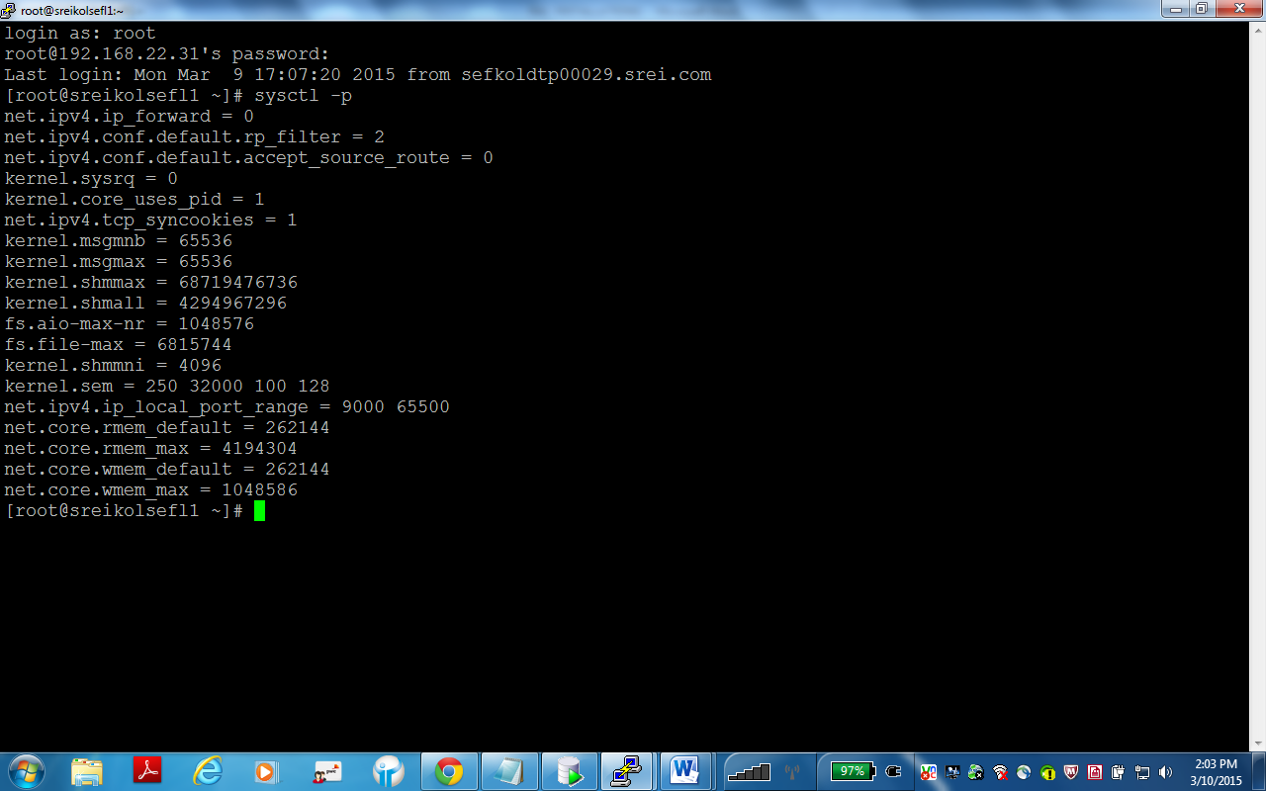

**6)Configuring security limits.conf file**

Vi /etc/security/limits.conf

orasp01 soft core unlimited

orasp01 hard core unlimited

orasp01 soft memlock 50000000

orasp01 hard memlock 50000000

orasp01 soft nproc 4096

orasp01 hard nproc 16384

orasp01 soft nofile 4096

orasp01 hard nofile 65536

gridsp01 soft core unlimited

gridsp01 hard core unlimited

gridsp01 soft memlock 60397977

gridsp01 hard memlock 60397977

gridsp01 soft nproc 4096

gridsp01 hard nproc 16384

gridsp01 soft nofile 4096

gridsp01 hard nofile 65536

:x

**7) NTP and other service configuration**

#/etc/init.d/avahi-daemon stop

#/etc/init.d/ntpd stop

#mv /etc/ntp.conf /etc/ntp.conf.old

**8)Configuring ASM disks**

# /usr/sbin/oracleasm configure –i.

This needs to be executed on all node

Output

Default user to own the driver interface []: gridsp01  
 Default group to own the driver interface []: dba  
 Start Oracle ASM library driver on boot (y/n) [n]: y  
 Fix permissions of Oracle ASM disks on boot (y/n) [y]: y  
 Writing Oracle ASM library driver configuration [ OK ]  
 Creating /dev/oracleasm mount point [ OK ]  
 Loading module "oracleasm" [ OK ]  
 Mounting ASMlib driver filesystem [ OK ]  
 Scanning system for ASM disks [ OK ]

After getting required partitions from Infra team from storage,create the asm disks

#oracleasm createdisk OCR /dev/xvdc5 //for OCR

#oracleasm createdisk VOTE /dev/xvdc6 //for voting disk

#oracleasm createdisk DATA /dev/xvdc7 //for database

#oracleasm createdisk LOG /dev/xvdb5 //for archivelog

#oracleasm scandisks

On the second node only perform below commands, as disks are already created from first node

#oracleasm scandisks

#oracleasm listdisks

Ouput

DATA

LOG

OCR

VOTE

**9)creating mount points for installation of grid and database Home on both nodes**

#**mkdir –p /u01/grid**

**#mkdir –p /u01/rac**

**#chown –R oracle:oinstall /u01/grid**

**#chown –R oracle:oinstall /u01/rac**

**#chmod –R 775 /u01**

**10)Starting Installations of grid infrastructure as grid user**

#xhost +  
$/newdump/filesystems/11_2_0_4_grid_64_bit/grid/runInstaller and the screenshot follows the installations

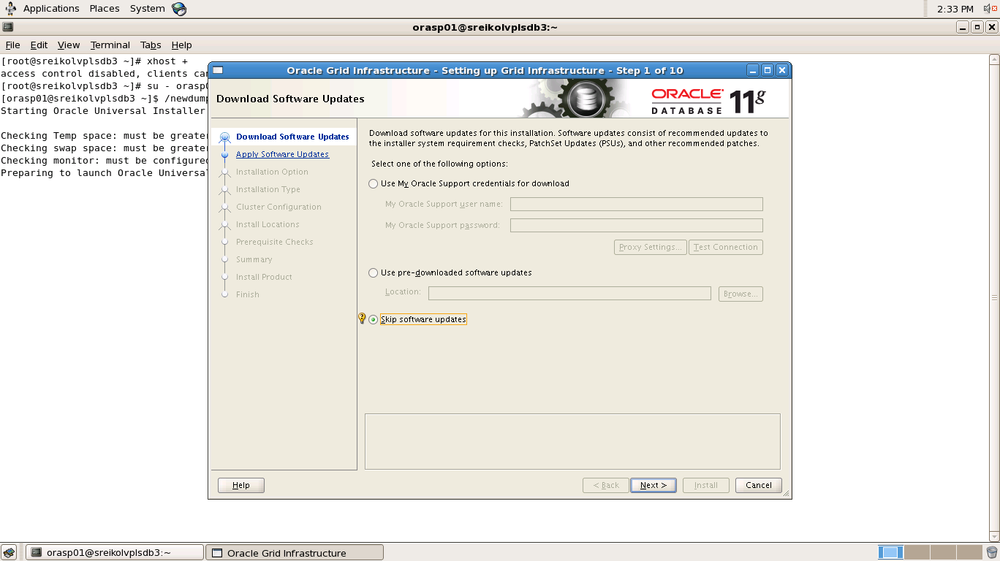

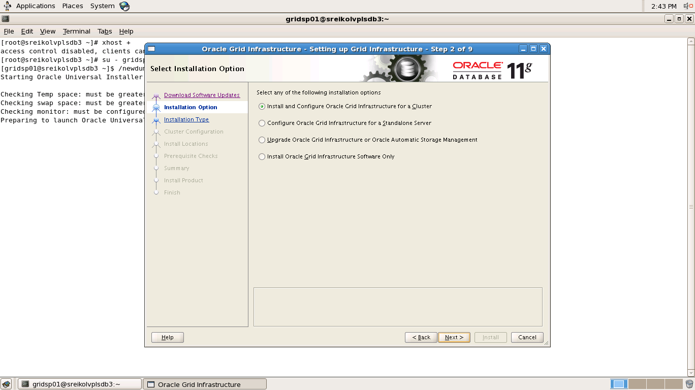

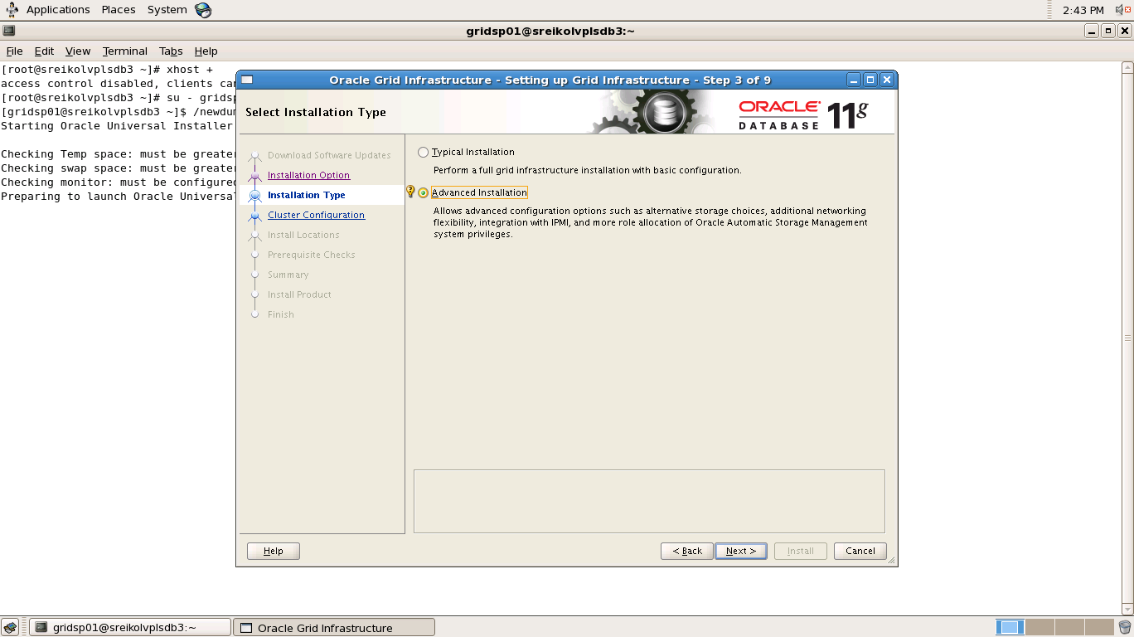

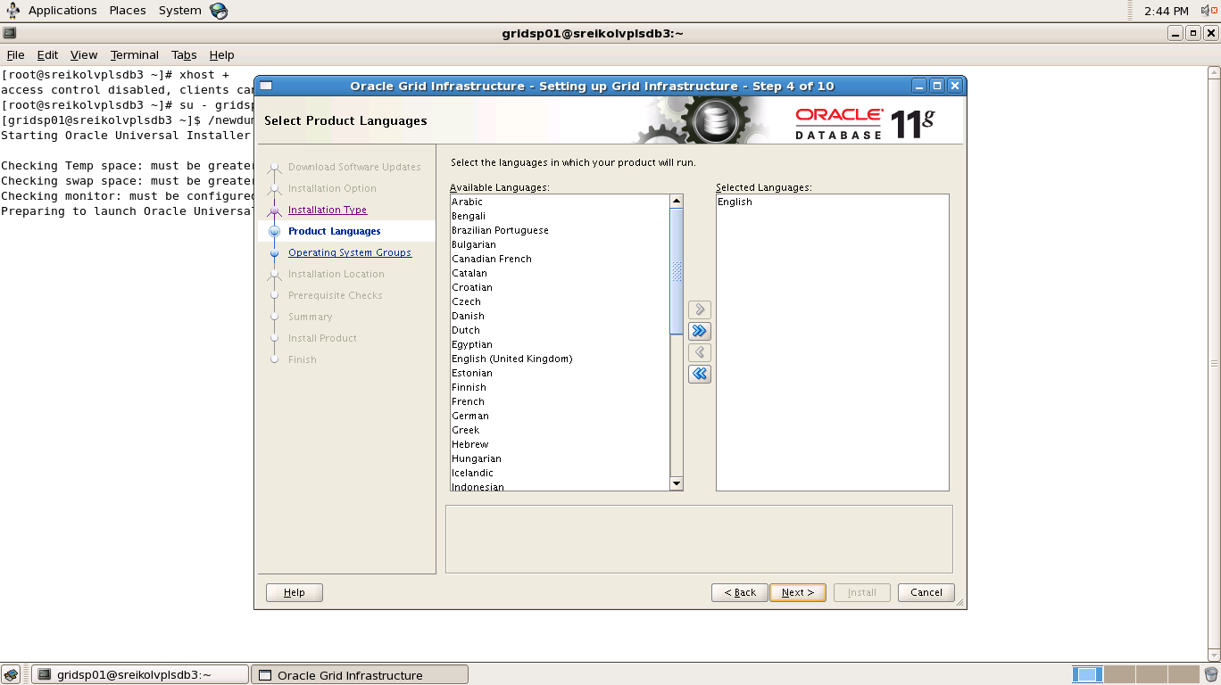

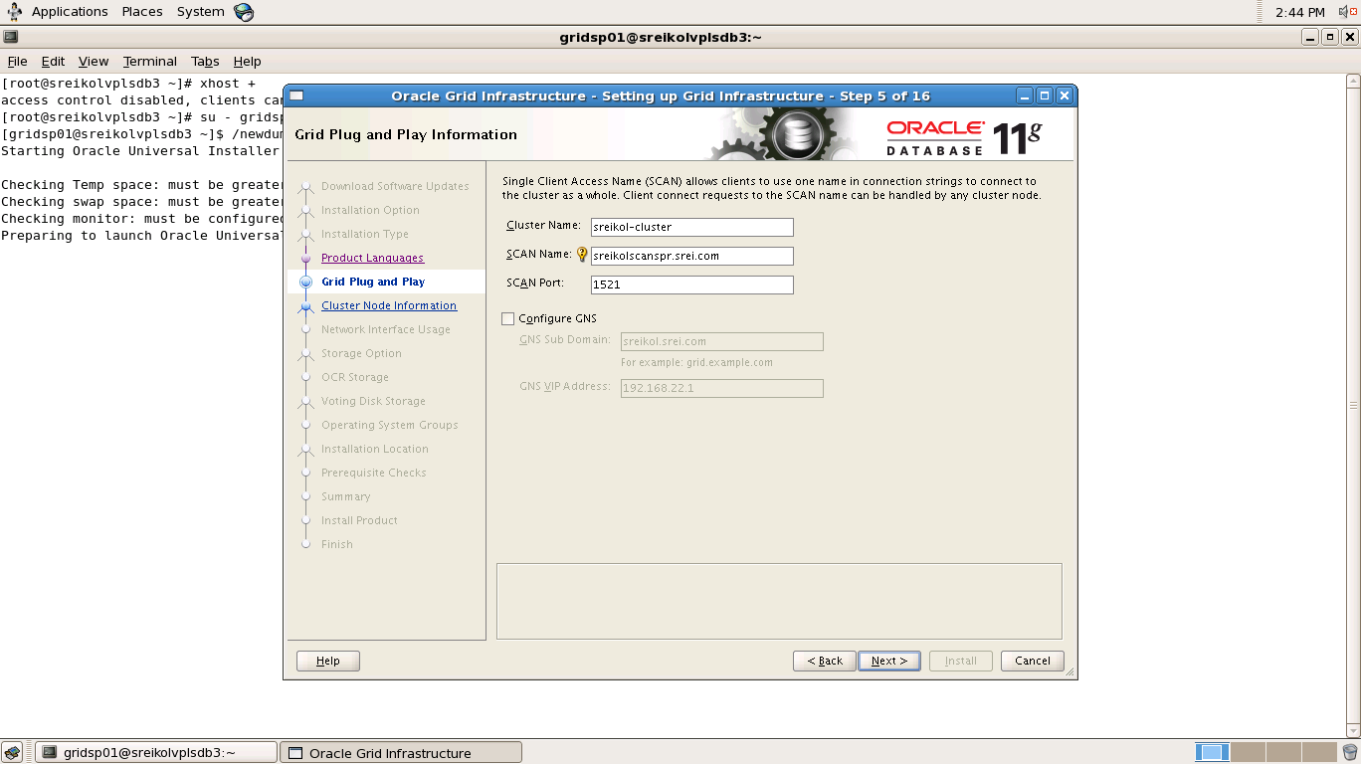

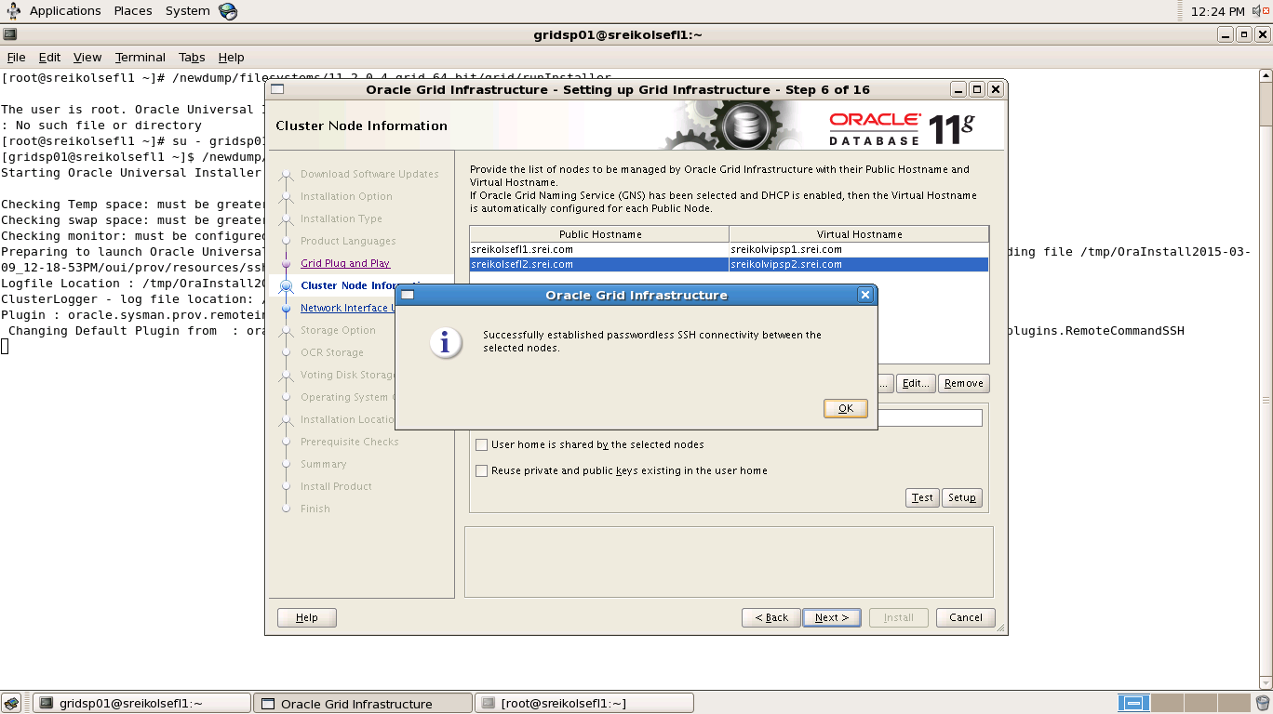

In the above screenshot it is noted that after selecting both nodes and the grid user/password, click on setup (for setting up ssh passwordless login, unlike 10G RAC) and then you will get screen as above

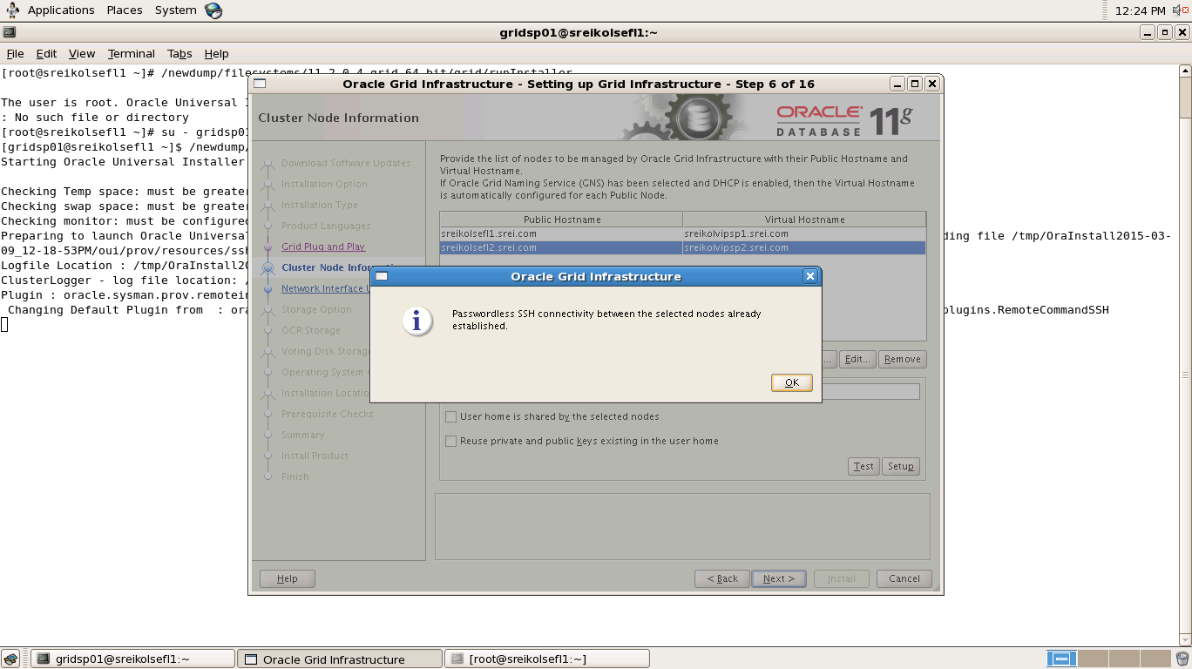

click on test and the result will be like the screen above.

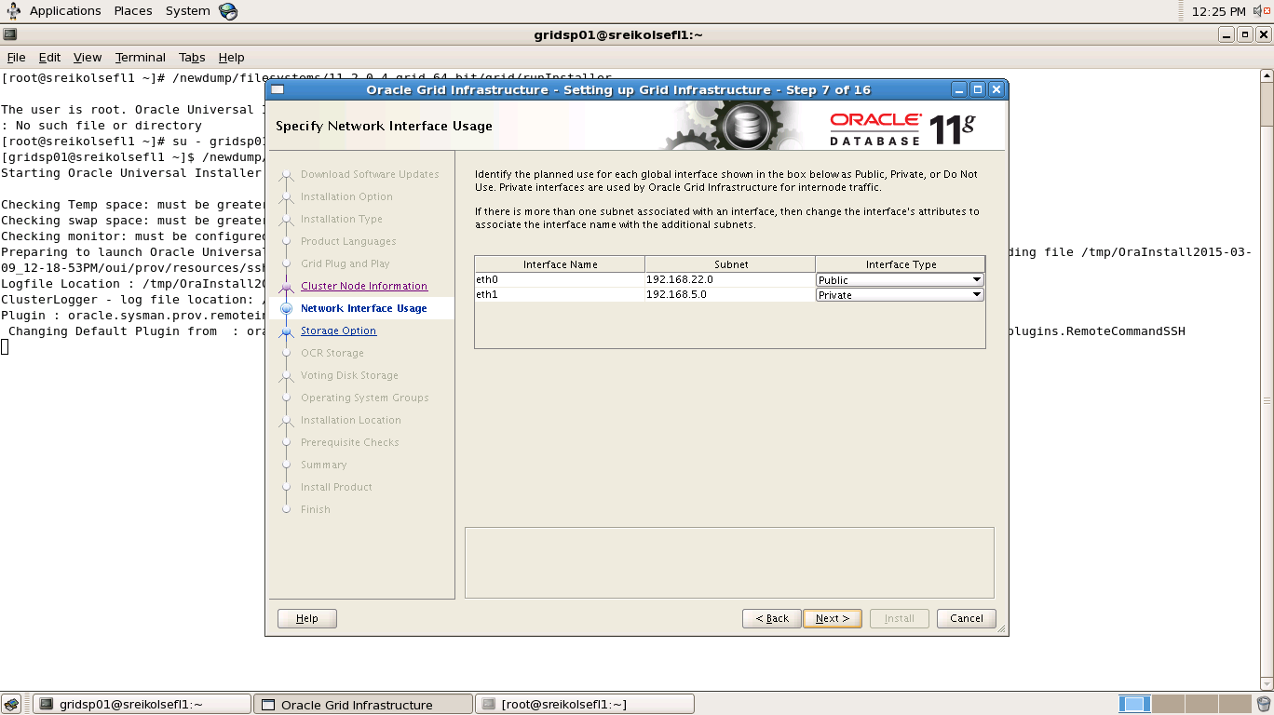

In the above screenshot mention the NICS used for public and private IPs

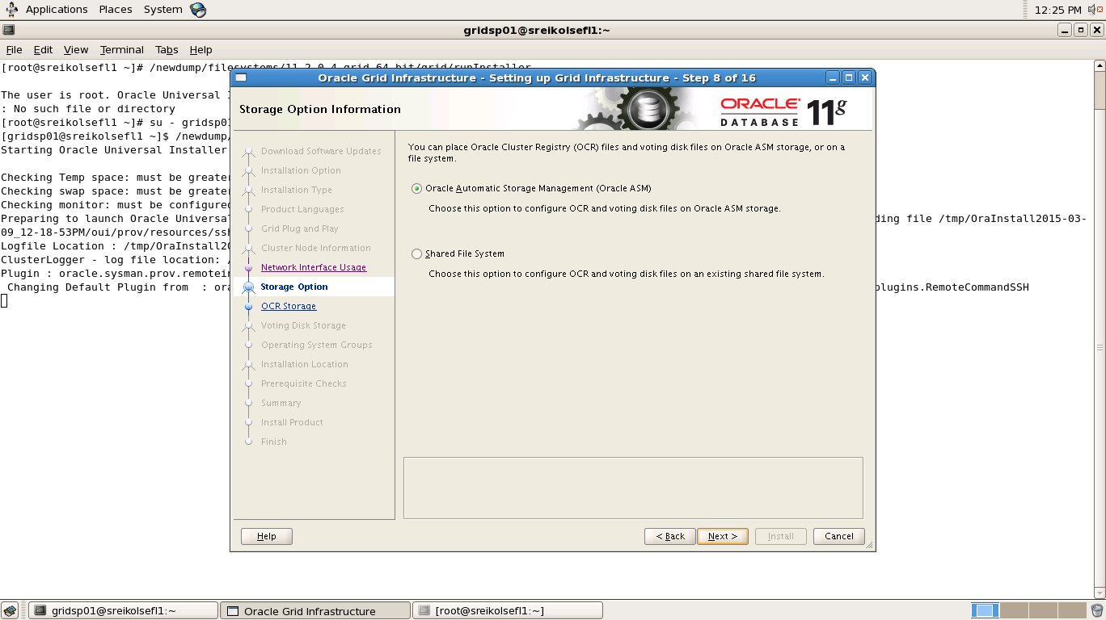

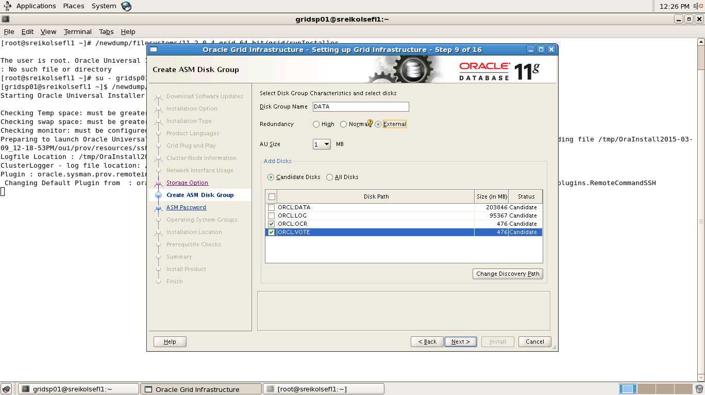

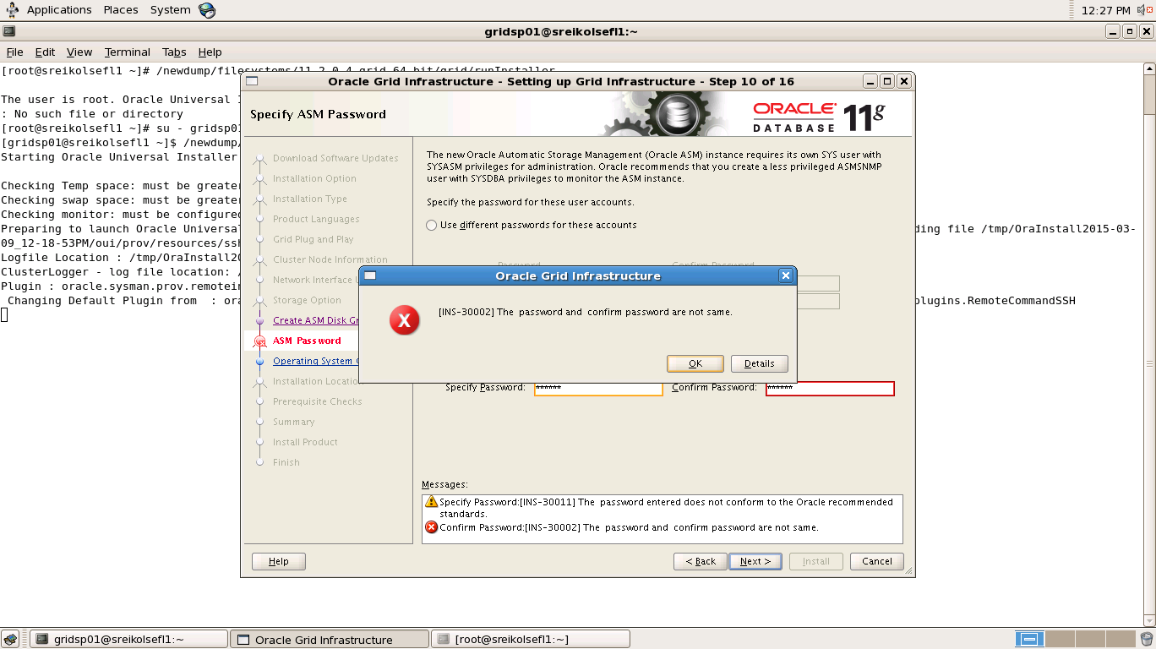

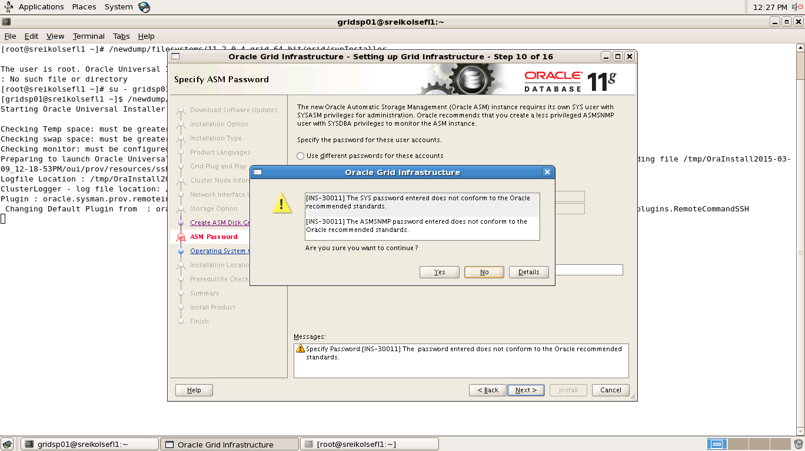

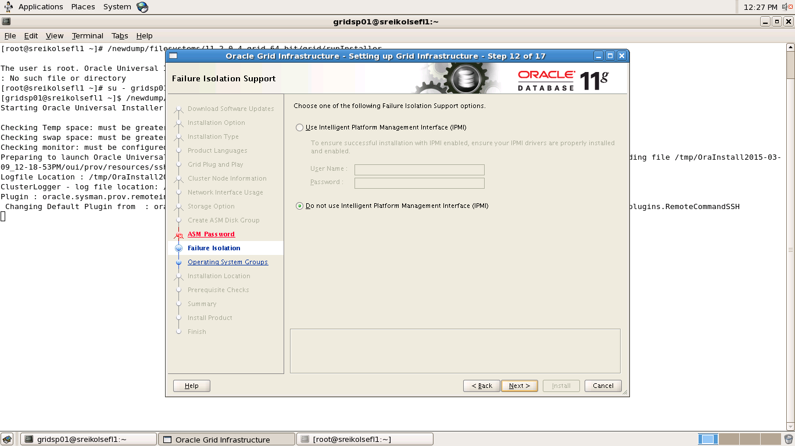

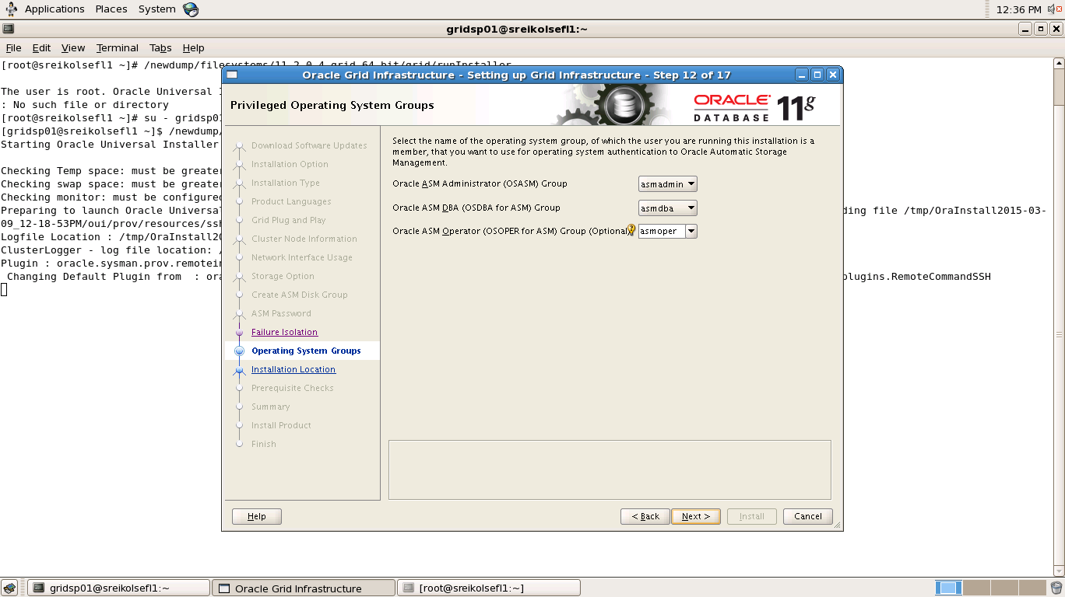

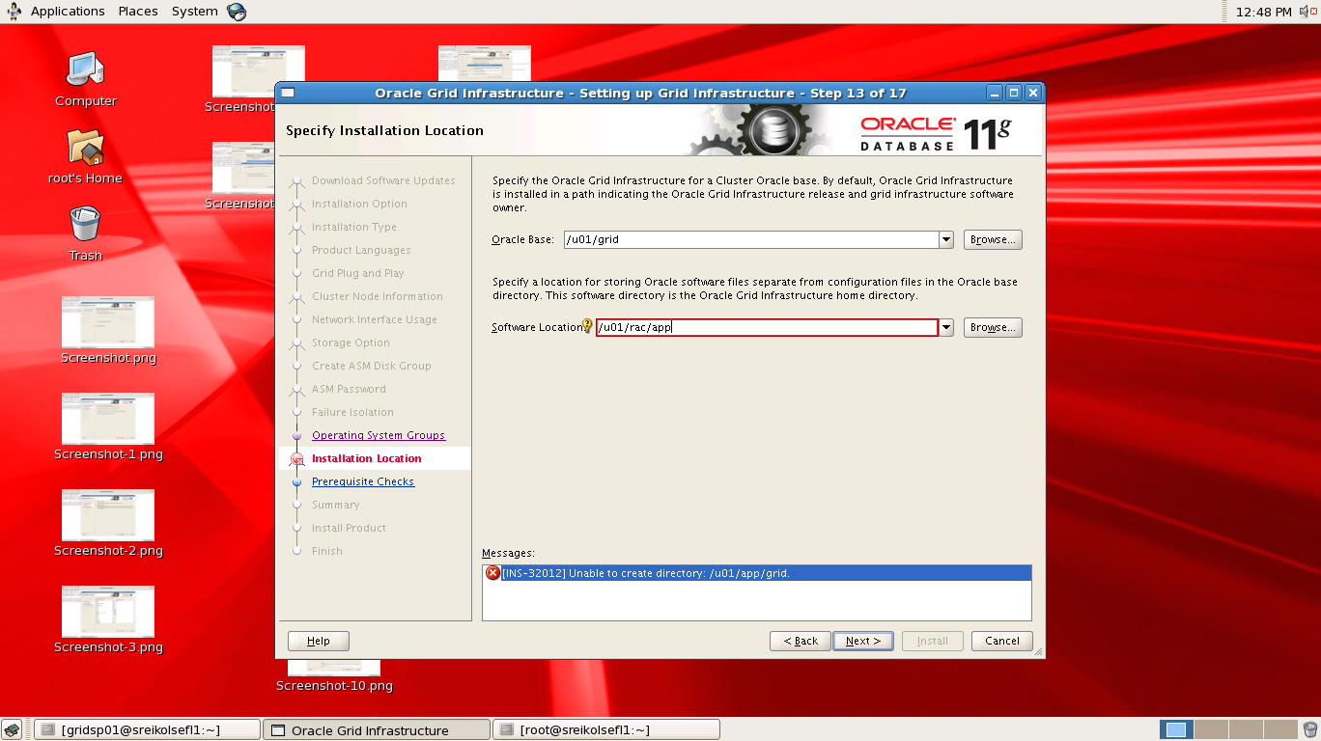

In the above screenshot note that oracle Base and oracle home for grid installations needs to be in different directories

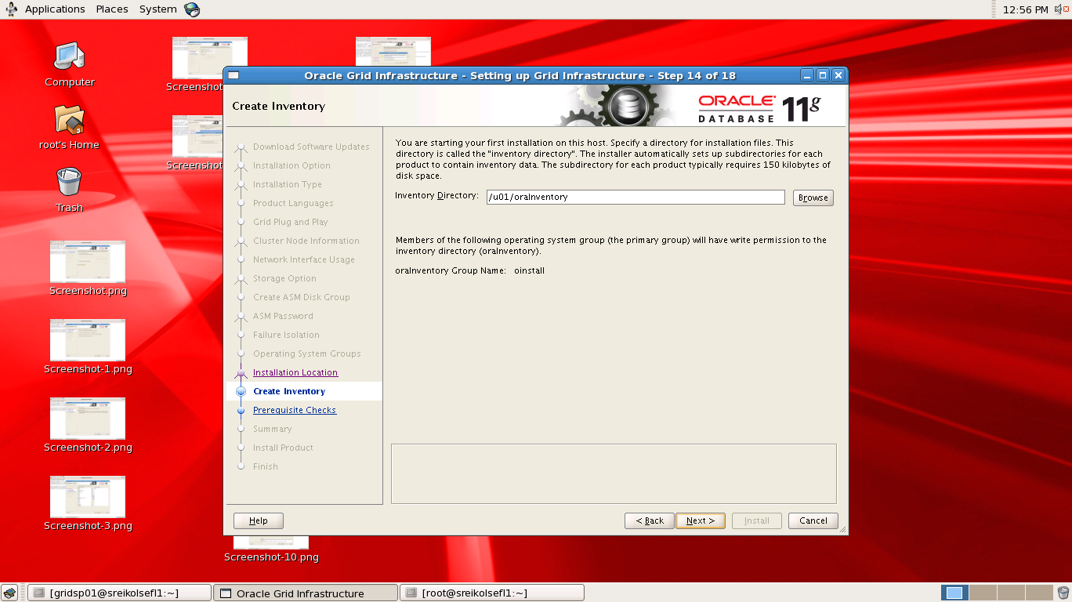

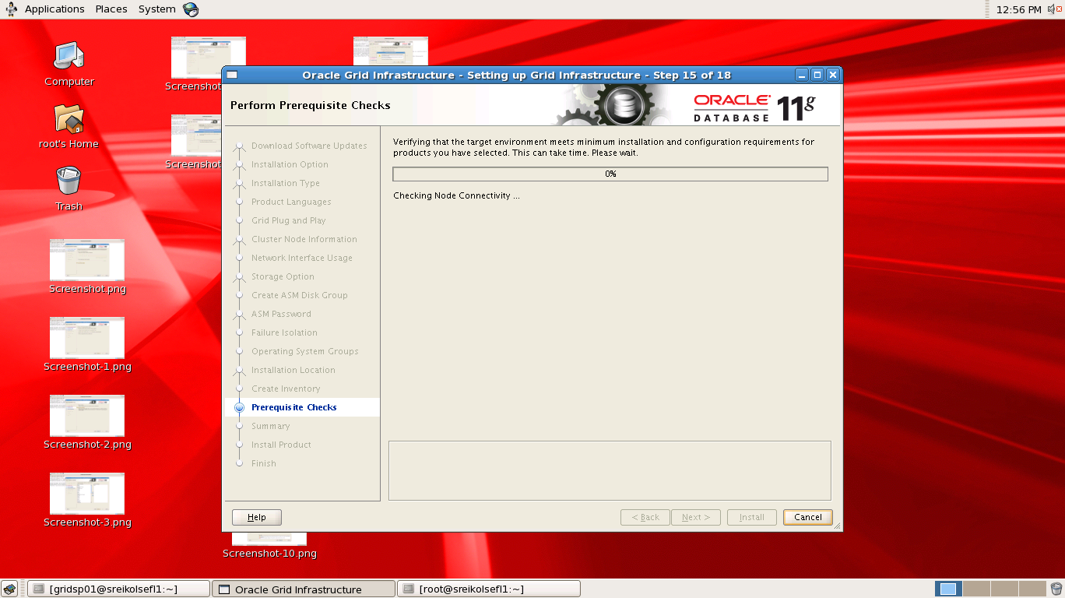

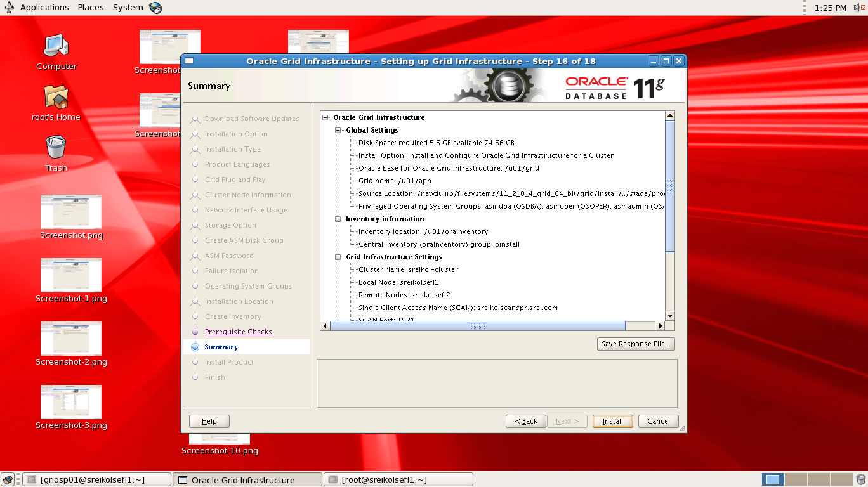

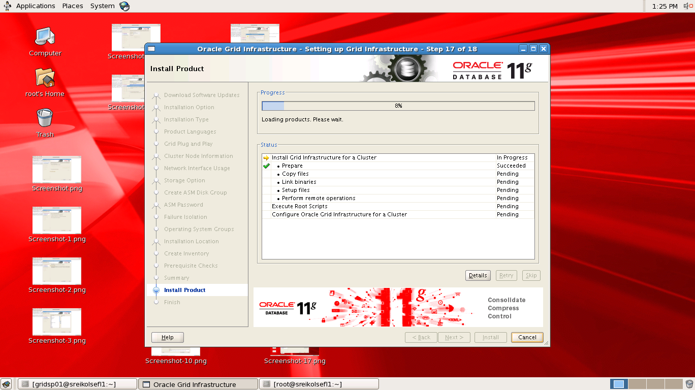

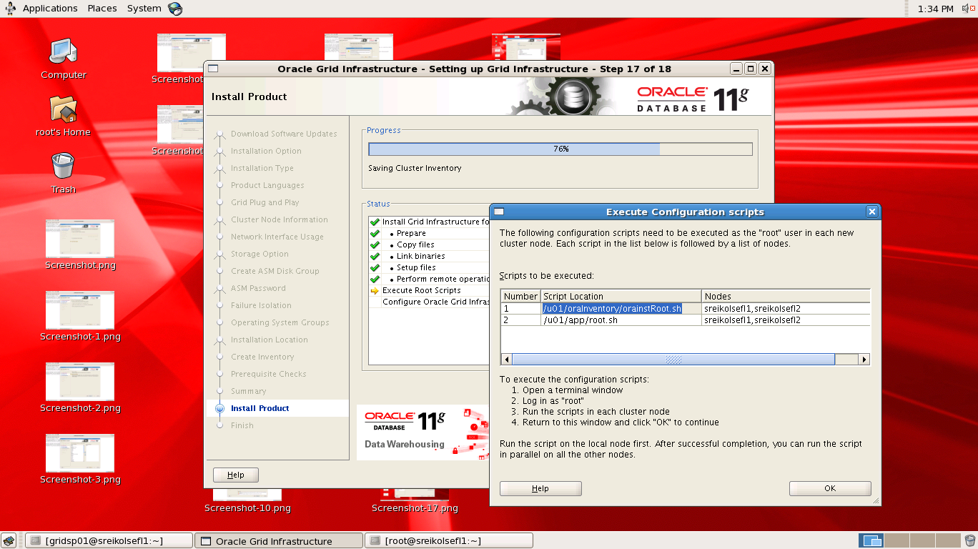

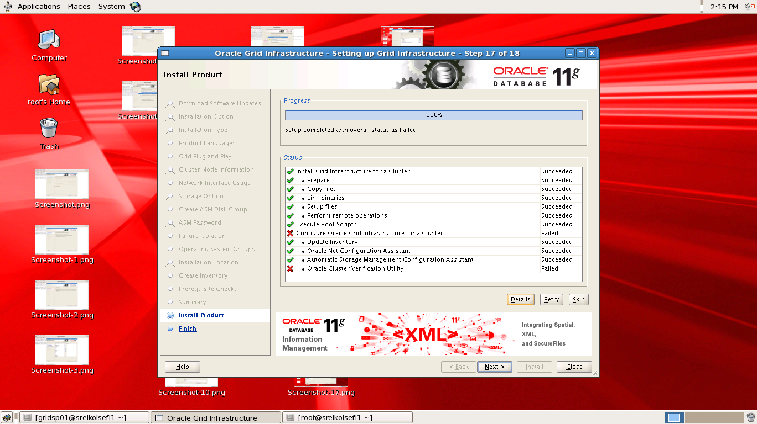

**/u01/app/root.sh**

**Ouput**

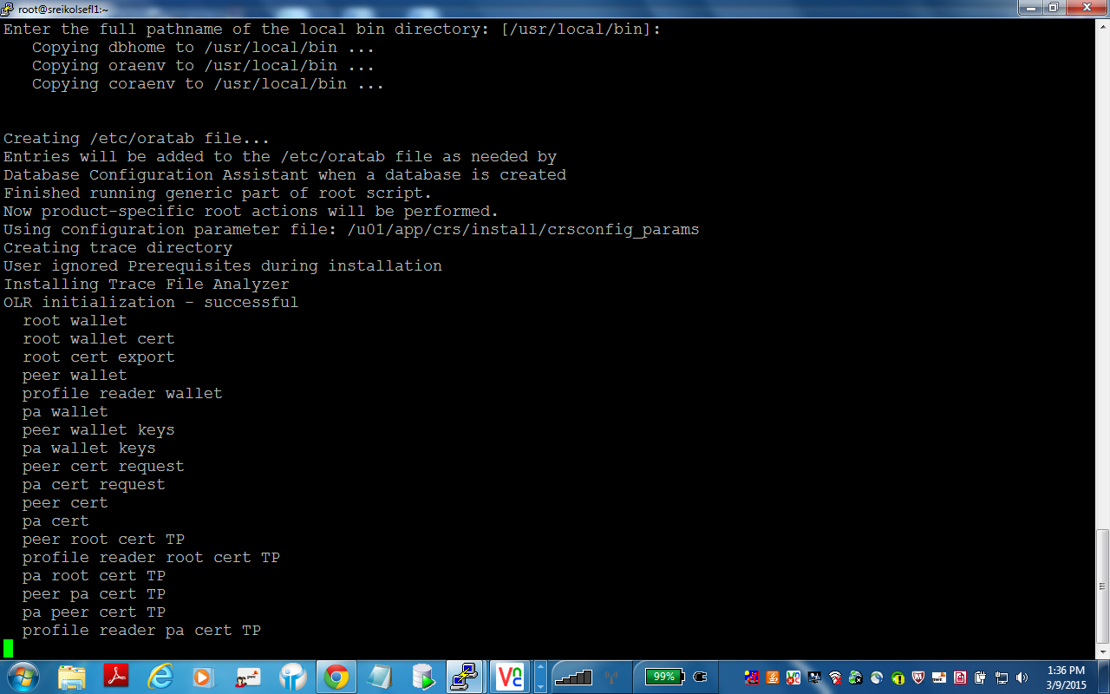

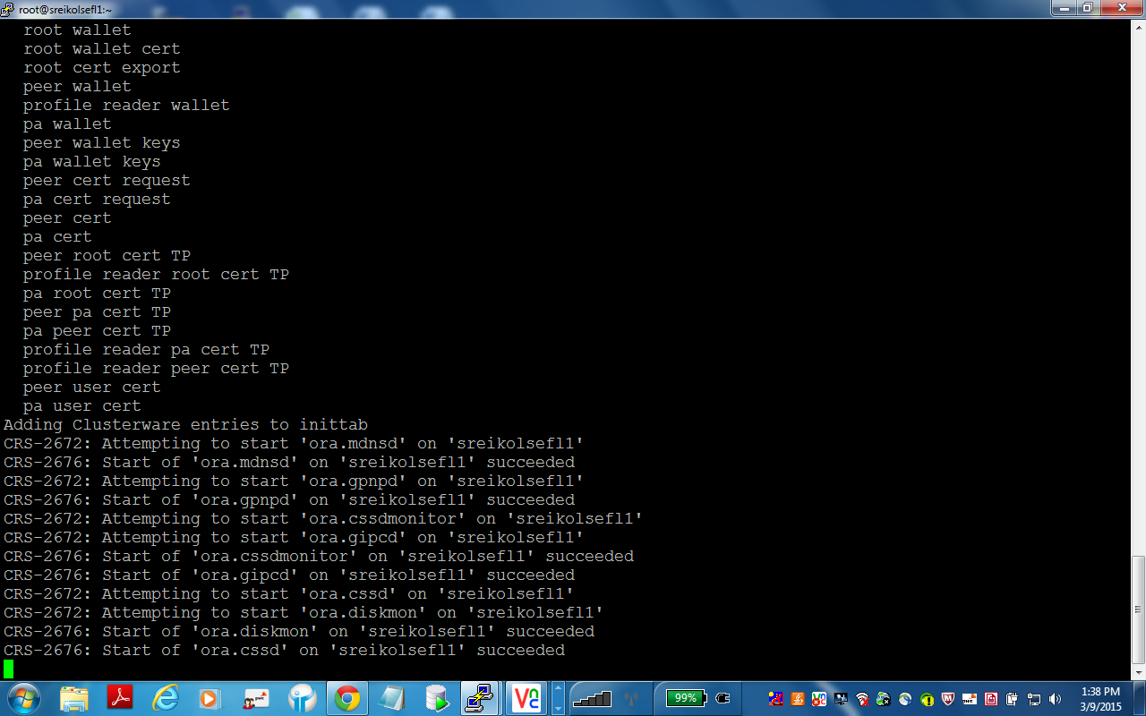

**11)ASM Configuration**

Login as griduser as before to run ASMCA and create diskgroup for archivelog and any other if required1.e Sasmca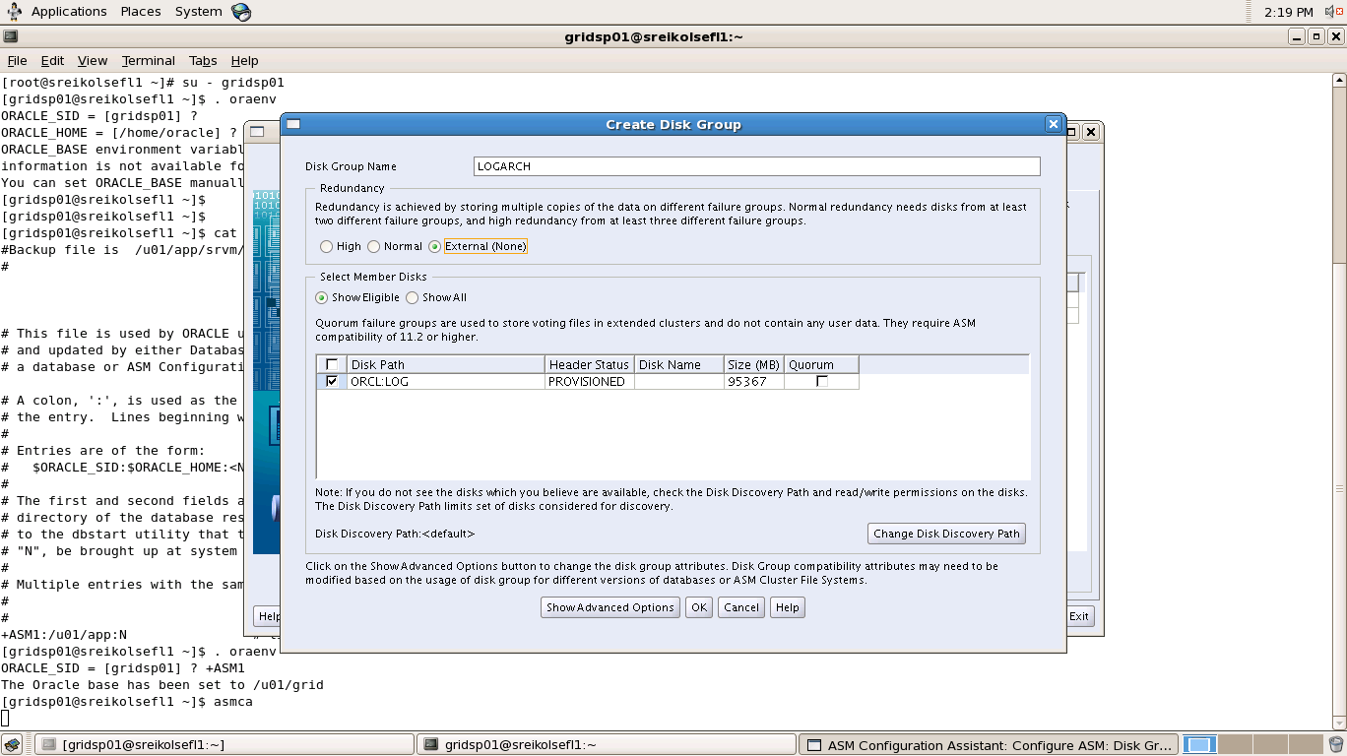

**12)Installation of database**

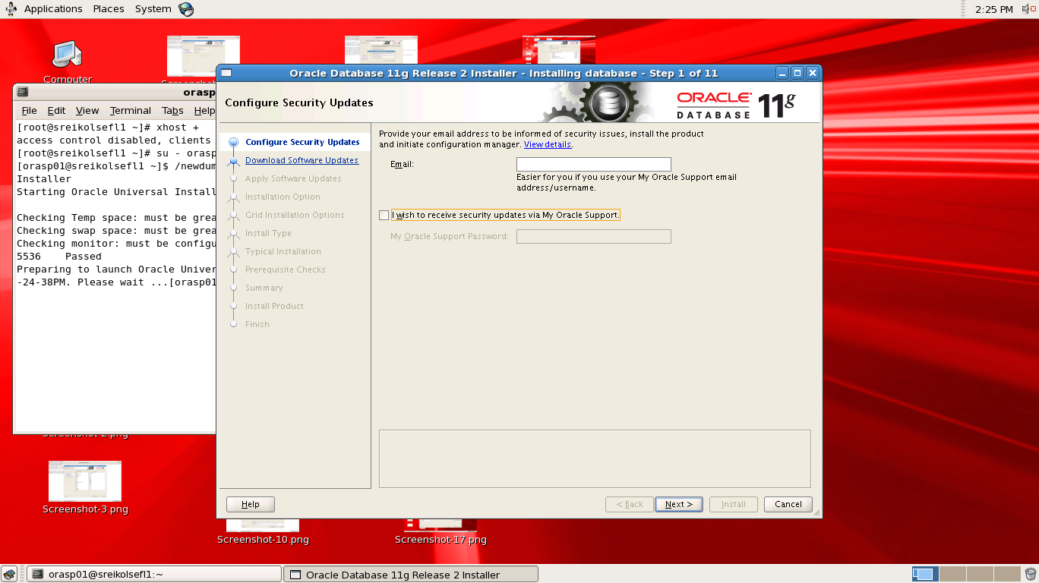

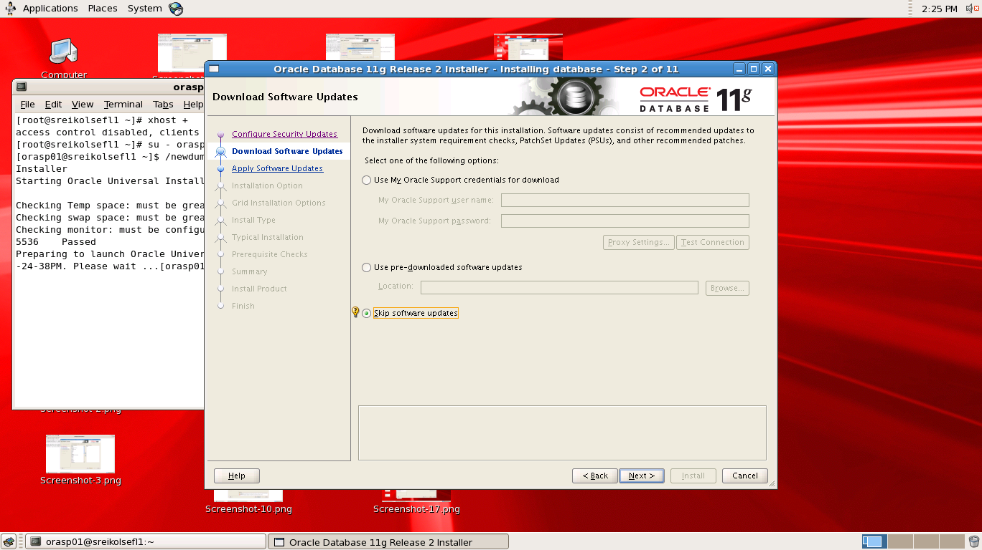

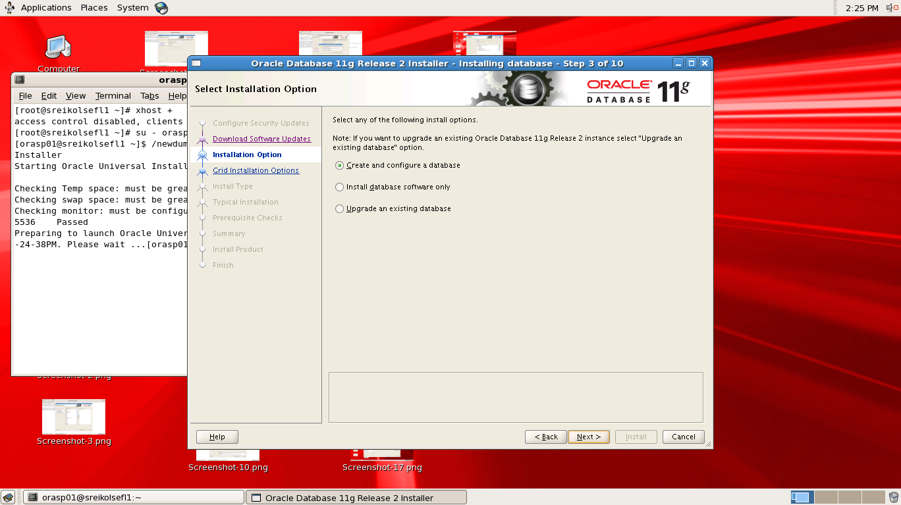

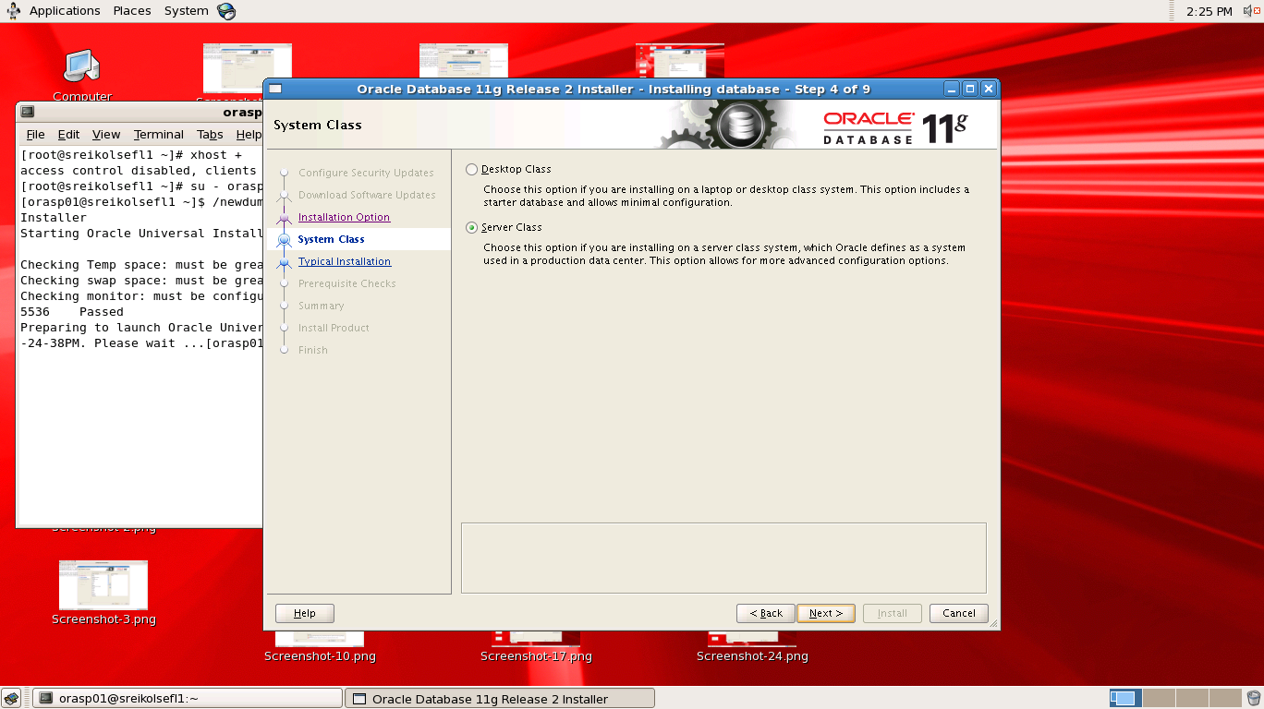

**In** 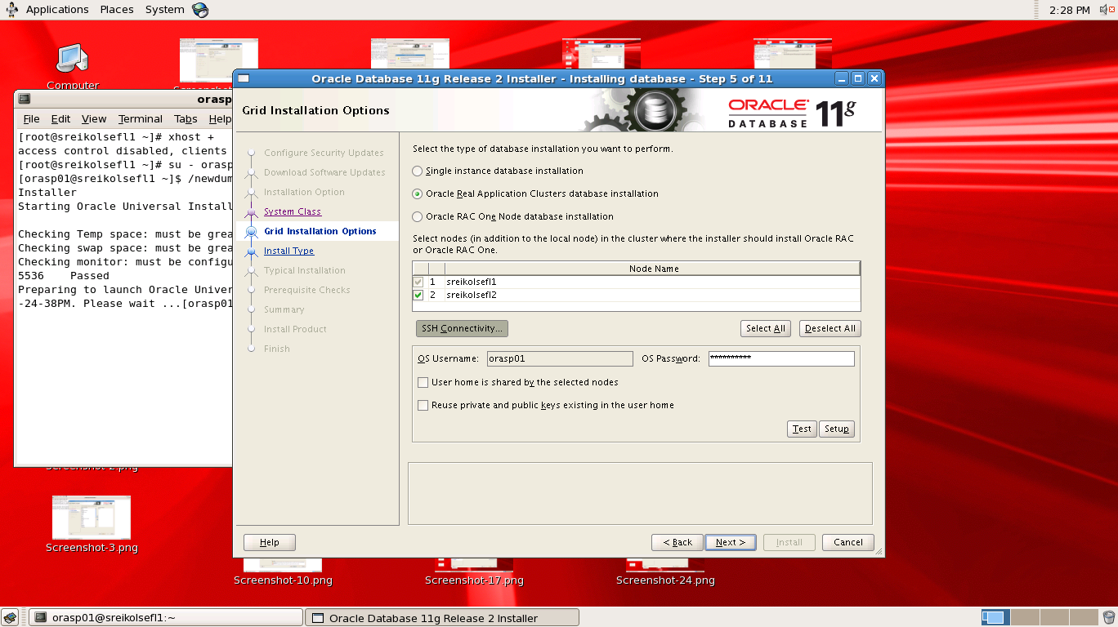



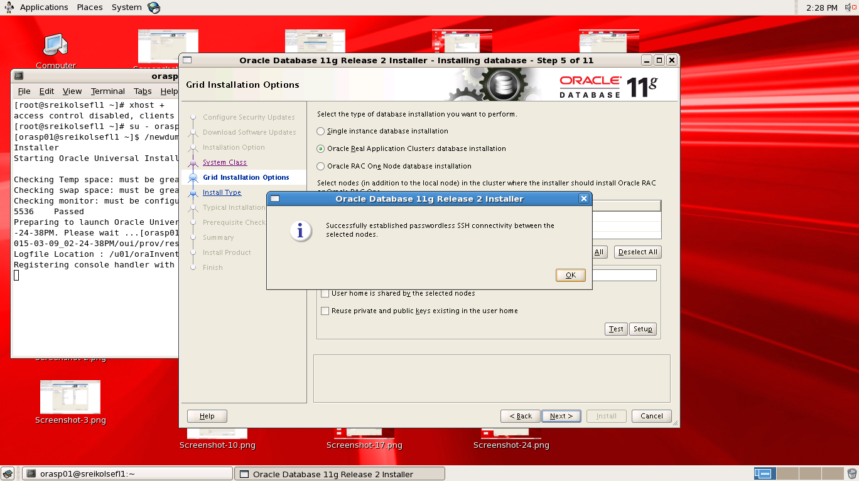

In the above screenshot ,like grid installation ,in db installations select all nodes and login as db user/password and then click on set up(for creating passwordless login b/w db users )

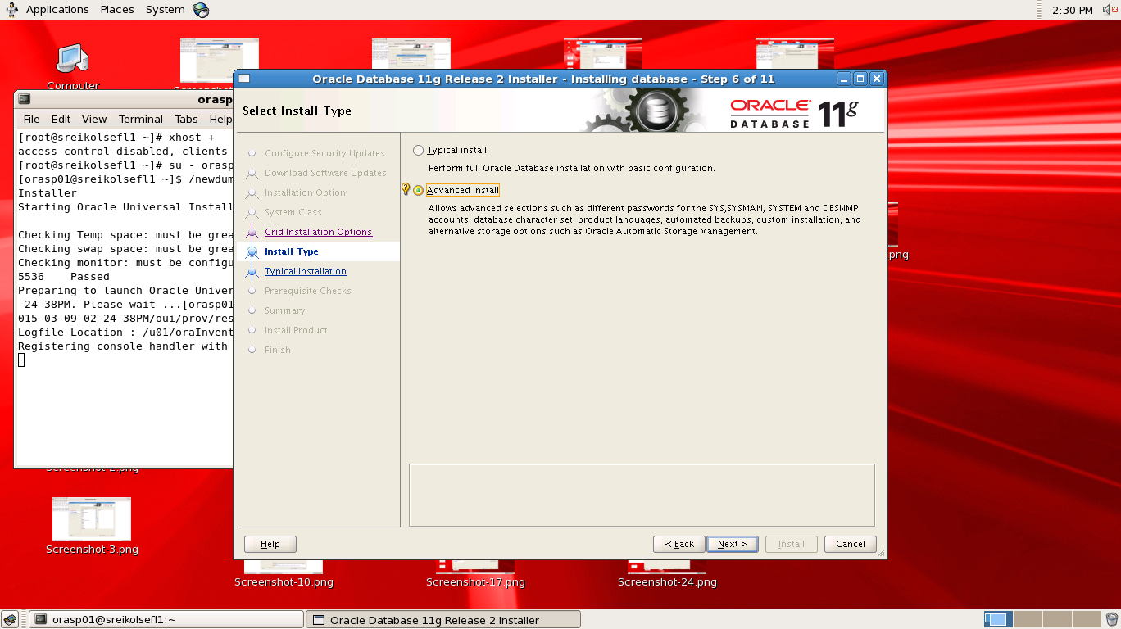

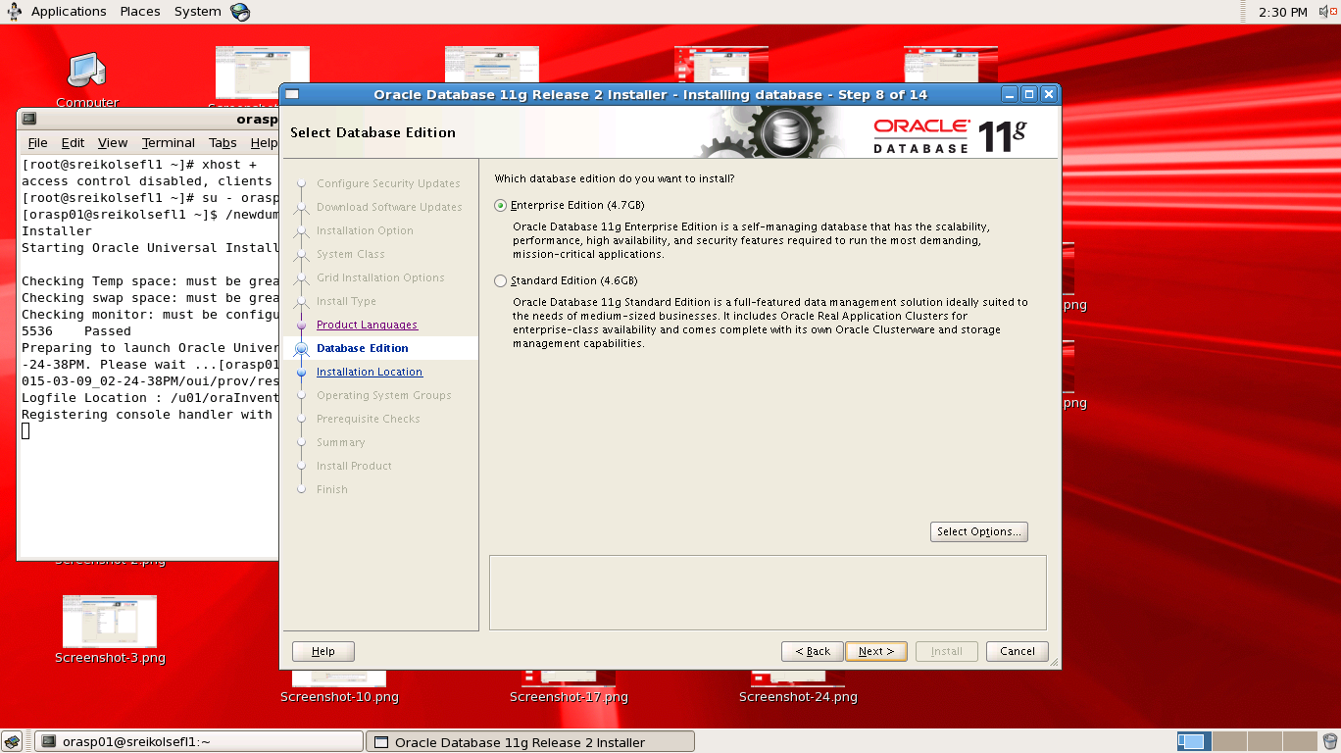

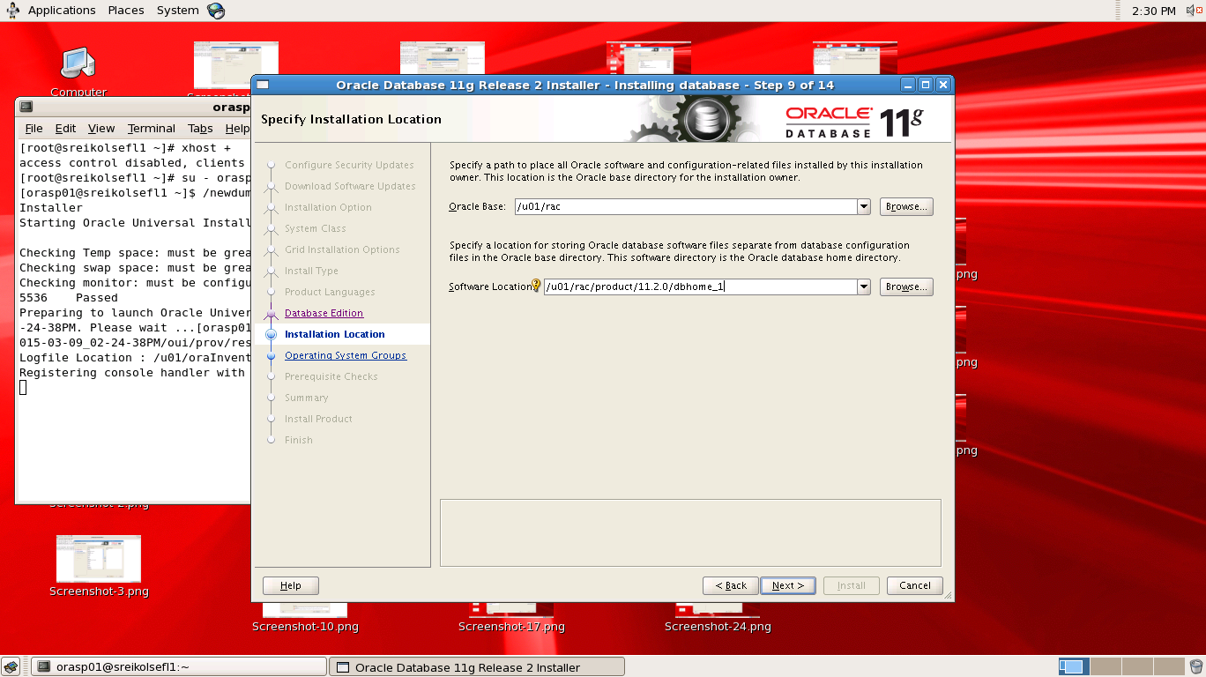

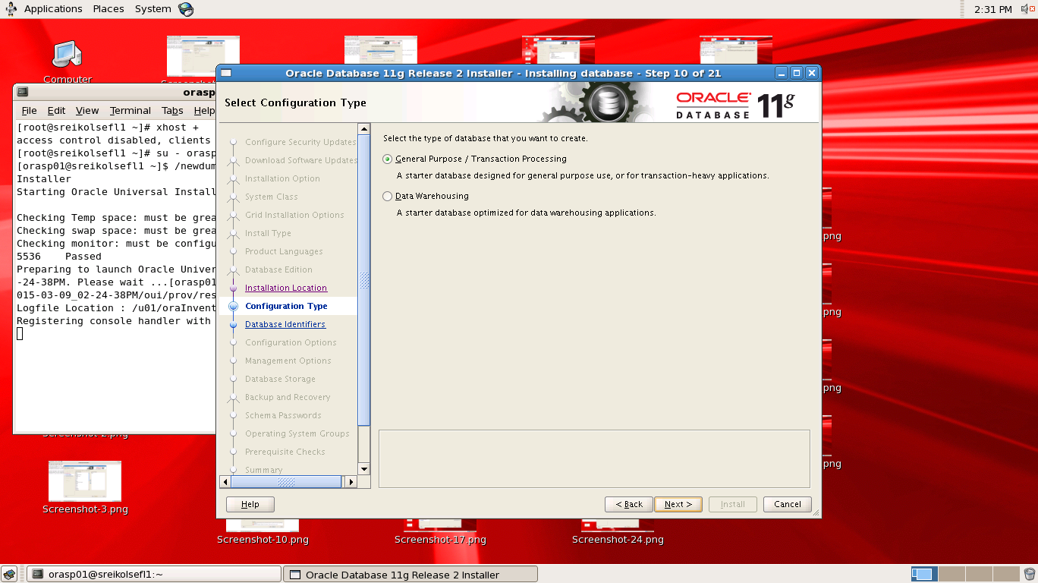

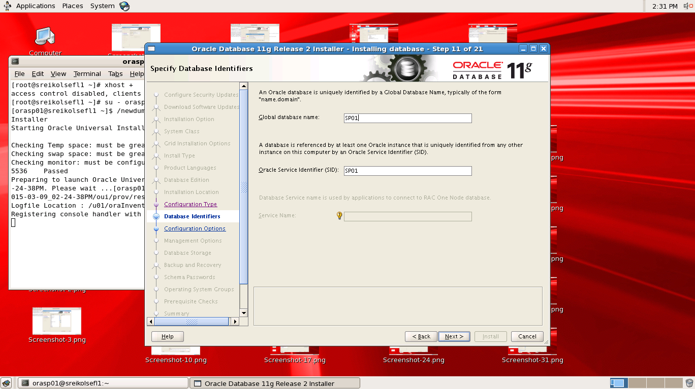

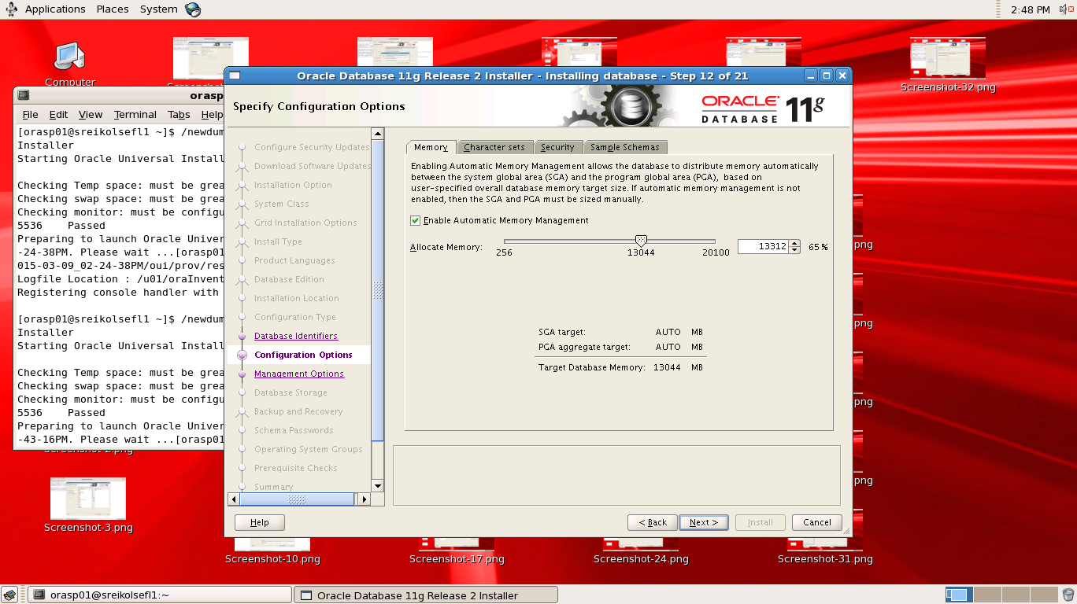

Choose the character set as UTF-AL32UTF8 as found in below screenshot

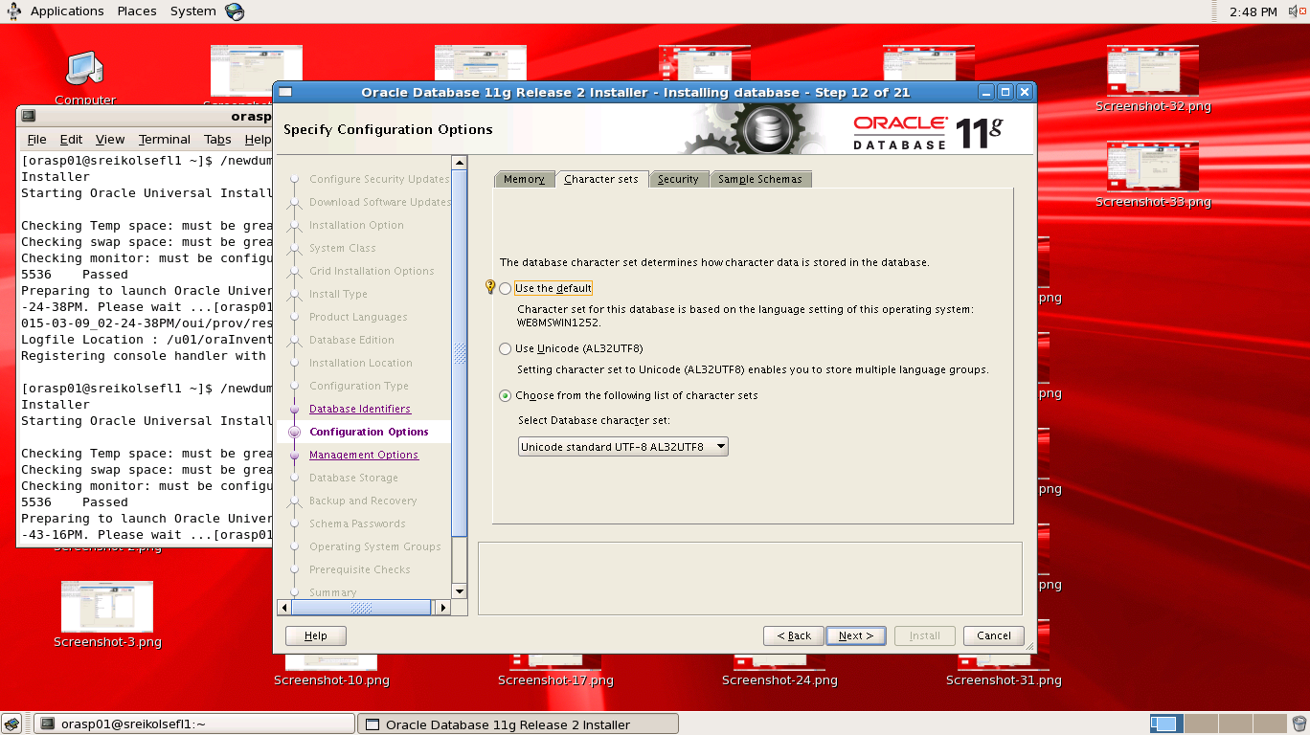

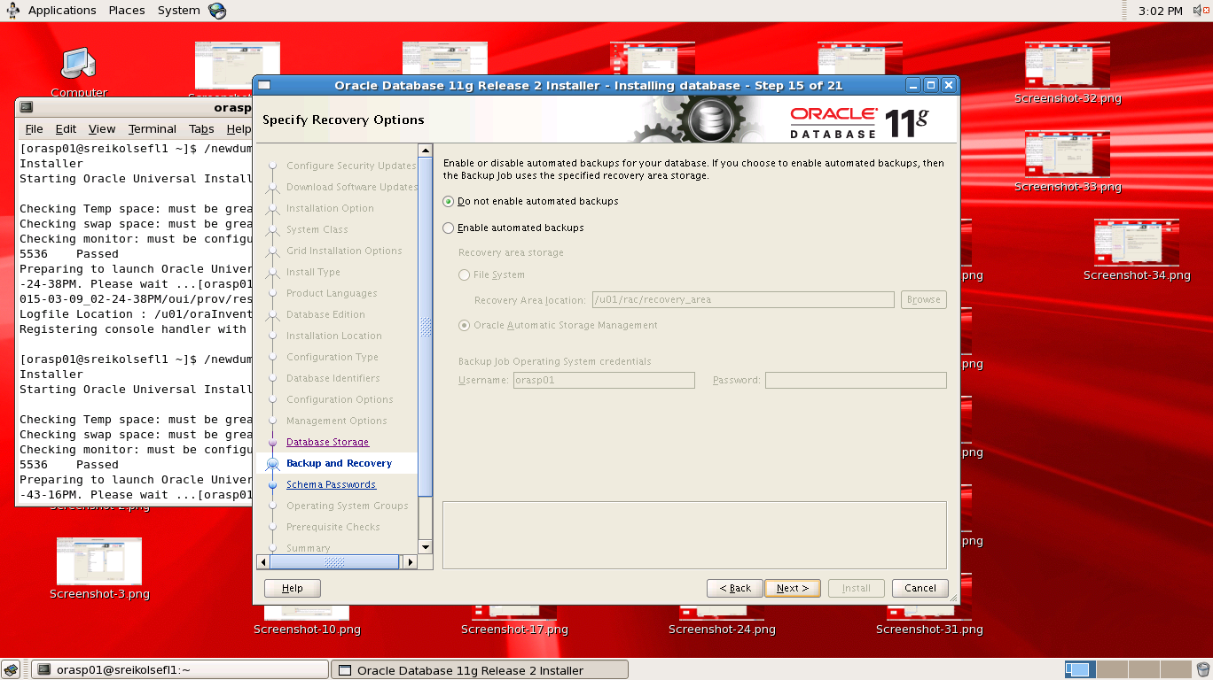

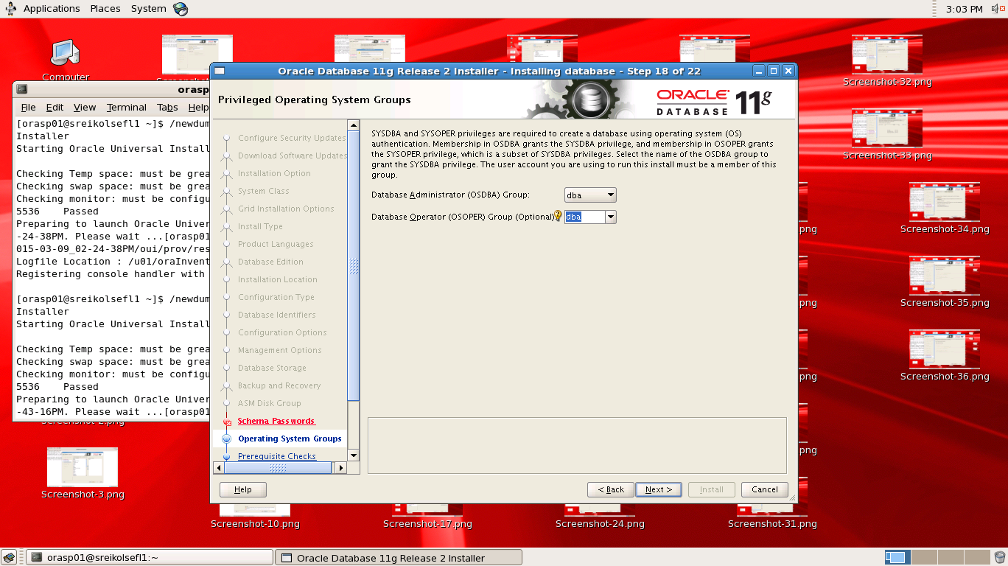

As Visible from above screenshot choose both the group as dba

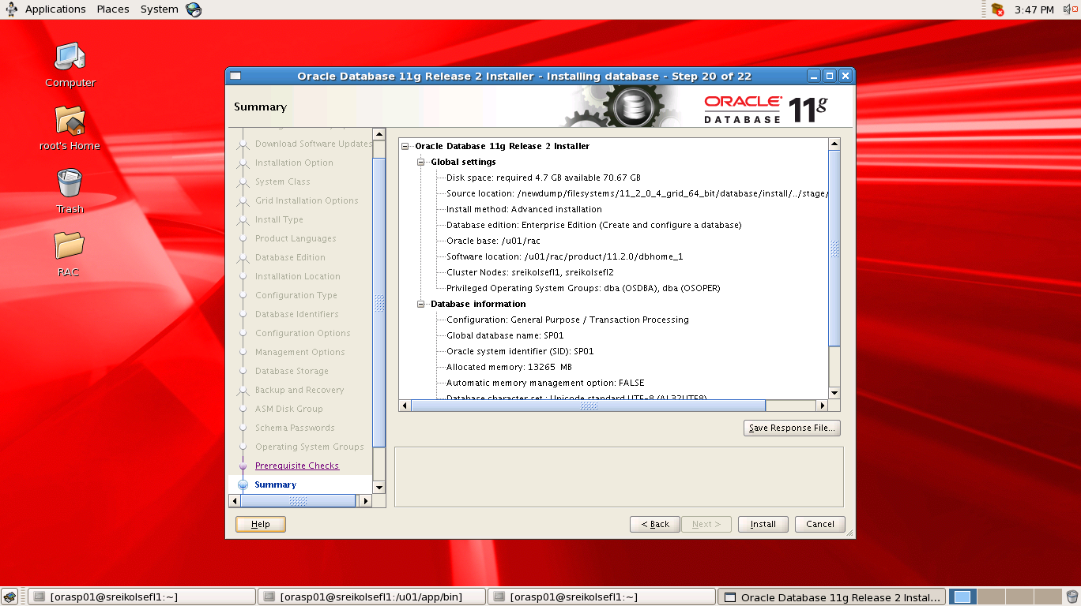

This is the end of DB and entire RAC installations .